REPORT 1

HR EMPLOYEE ATTRITION:

The KPI’s used in the dashboard are: percentage of attrition, total employees and total attrition.

* percentage of attrition is 16.12 %
* total employees are 1470
* total attrition is 237 employees

1] The bar chart represents the number of attritions distributed among the gender the attrition in males is 150 and that in females is 87.

2] The column chart shows the job satisfaction of the employees:

The number of employees who have rated job satisfaction as 4 are 459.

The number of employees who have rated job satisfaction as 3 are 442.

The number of employees who have rated job satisfaction as 2 are 280.

The number of employees who have rated job satisfaction as 1 are 289.

3] In the next column chart describes the attrition distributed along various ages:

The total attrition is maximum for ages 29 and 31 which is 18 for both. Basically the attrition is maximum in the age ranging from 26 to 35.

4] To see how the attrition is distributed among various educational fields we have used the pie chart :

We can see that :

* The percentage of attrition for the life sciences is 37.55%
* The percentage of attrition for the Medical is 26.58%
* The percentage of attrition for the Marketing is 14.77%
* The percentage of attrition for the Technical Degree is 13.5%
* The percentage of attrition for the other is 4.64%
* The percentage of attrition for the Human resources is 2.95%

5] To see how the attrition is distributed among various department we have used the doughnut chart :

* The percentage of attrition in Human resources department is 5.06%
* The percentage of attrition in research and development department is 56.12%
* The percentage of attrition in Sales department is 38.82%

The following is the bar chart which shows the employee attrition.

As we can see that the total attrition is quite less compared to people who do not leave the company.

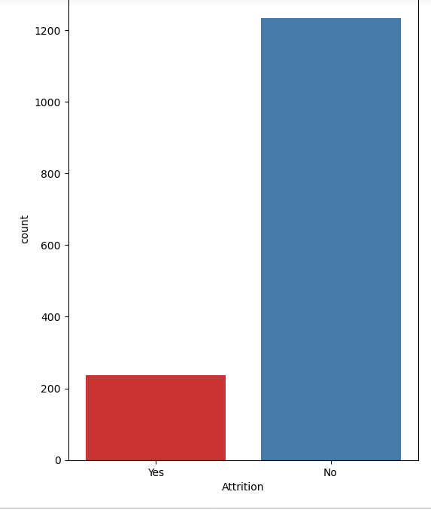

KEY INSIGHTS:

* The total attrition is higher in males than females.
* Most of the employees are satisfied with their jobs as , 459 employees rated job satisfaction as 4 and 442 employees rated job satisfaction as 3.
* The total attrition is maximum for ages 29 and 31. The lowest is for the ages 49,50 and 51
* The maximum attrition is found in the life science field and medical field and the lowest in human resource.
* The attrition is maximum in the research and development department which is 56.12 % and the lowest is in the Human resources department which is 5.06%.